**Day 2**

**AUC Robotics Summer Camp**

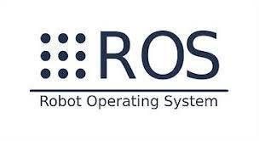

[**https://www.noor-book.com/%D9%83%D8%AA%D8%A7%D8%A8-%D8%A3%D9%88%D8%A8%D9%86%D8%AA%D9%88-%D8%A8%D8%A8%D8%B3%D8%A7%D8%B7%D8%A9-pdf**](https://www.noor-book.com/%D9%83%D8%AA%D8%A7%D8%A8-%D8%A3%D9%88%D8%A8%D9%86%D8%AA%D9%88-%D8%A8%D8%A8%D8%B3%D8%A7%D8%B7%D8%A9-pdf)

**Content :**

* **Why Linux**
* **Linux Distribution**
* **Installing ubuntu on laptop**
* **Installing ubuntu Virtualbox**
* **Basic understanding ubuntu**
* **Dealing with terminal commands**
* **Installing ROS on ubuntu 16.04 LTS**
* **Testing ROS installation**

**Why linux**

* Free, Safe, Robust. Source code of all related SW is available.
* Large device drivers’ coverage.
* Hosting a huge number of languages & libraries.
* **Support ROS**
* Large Community.

**Linux Distribution**

-Major Linux distributions families

RedHat RedHat Enterprise

Centos

Fedora

Debian

**Ubuntu**

SUSE SUSE Enterprise OpenSUSE

**Installing ubuntu on laptop**

* <https://www.linuxtechi.com/install-ubuntu-16-04-with-screenshots/>

**Installing ubuntu Virtualbox**

* <https://websiteforstudents.com/how-to-install-ubuntu-16-04-17-10-18-04-guest-machines-on-virtualbox/>

**Basic understanding ubuntu**

* Explore ubuntu file system and others

**Dealing with terminal commands**

* **What is terminal**

So, basically, a shell is a program that receives commands from the user and gives it to the OS to process, and it shows the output.

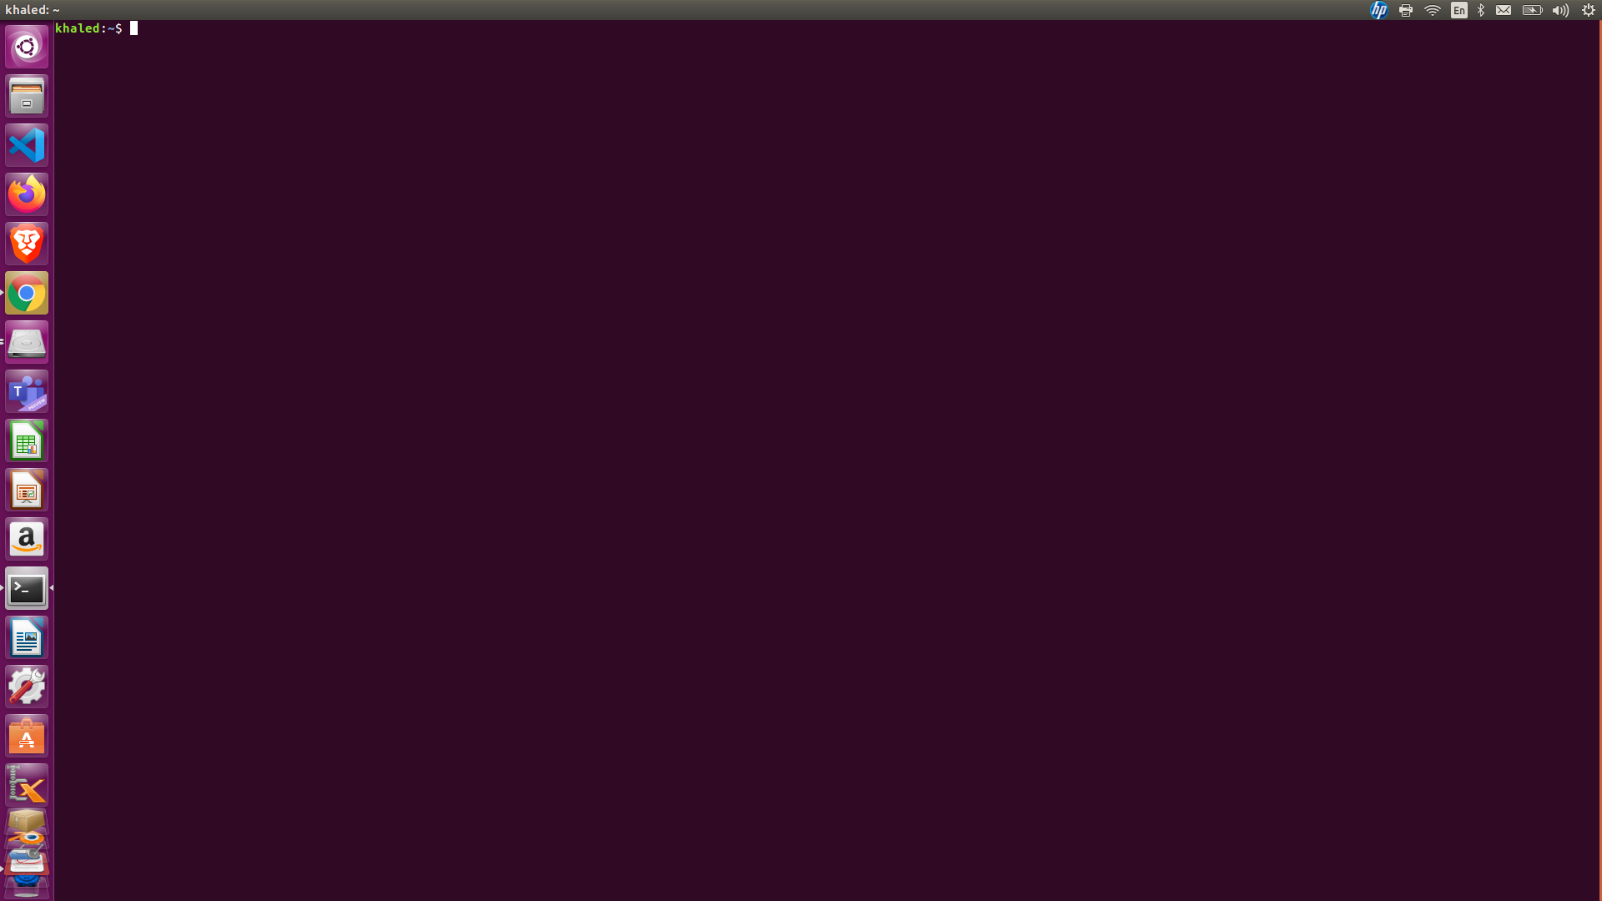

* Basics of Linux Commands

• $ cd – change directory

• $ ls – List the file in a folder

• $ pwd – print current working directory

• $mv – move & rename

• $ touch –create a new file

• $ cp – copy files and directories

• $ mkdir folder_name – Make a new

folder

• $ rm file_name – Delete a file

• $ rm -r dir_name – Delete a dir

• $ dmesg – List the kernel message

• $ lsusb – List usb devices

• $ sudo – Run with administrative privilege(SuperUser Do)

• $ kill PID – Stop a process

• $ htop – Process Manager

• $ sudo apt-get install htop

• $ sudo apt-get install – Install a package

• $ sudo reboot – Reboot the system

• $ sudo poweroff – Power of the system

**Installing ROS on ubuntu 16.04 LTS**

* <http://wiki.ros.org/kinetic/Installation/Ubuntu>

**Testing ROS installation**

• $ roscore – Test this command in terminal to verify ROS installation

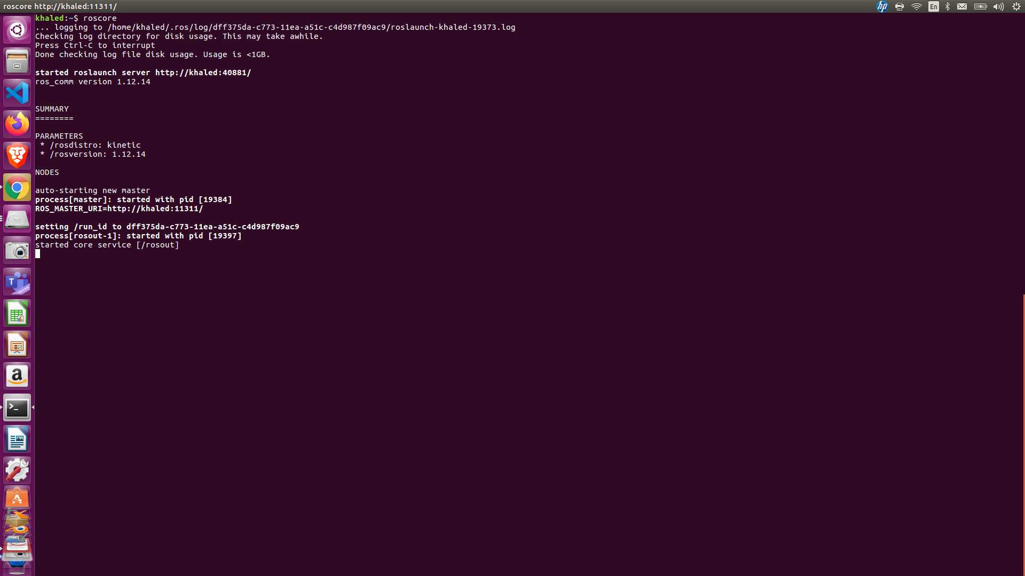

Thanks